CST-391

## Activity 0

Trevor Marr

Part 1 - Tools Installation and Hello World

A screenshot showing the install status and version of node and npm. I use node and npm daily for my Angular app.

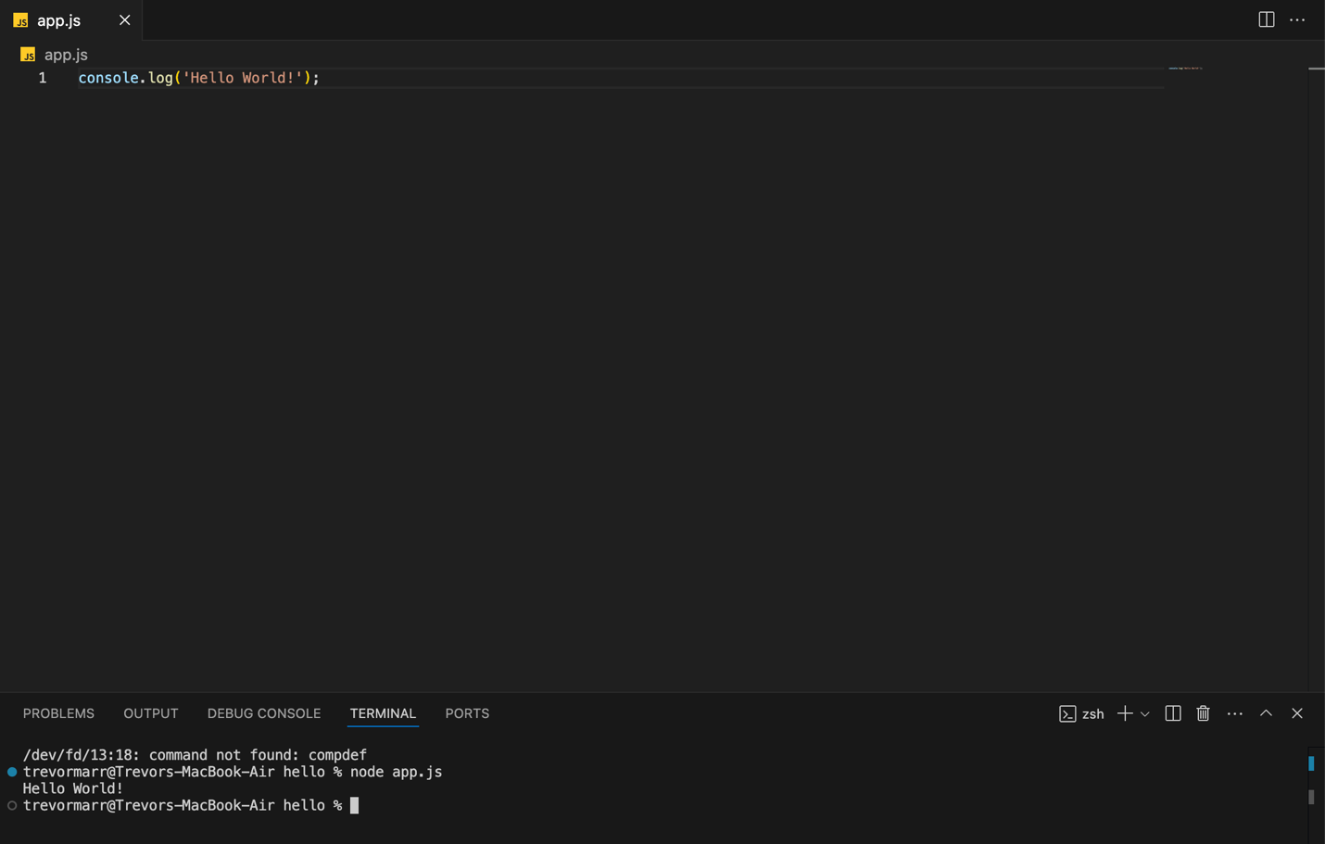

A screenshot showing the new HelloWorld output in the console from app.js with node.

A screenshot showing the Express server running on port 300 and displaying Hello World.

A screenshot showing that nodeman works and applied new changes to the code.

Part 2 – Node.js with TypeScript

Hello World from typescript running as an Express server on localhost:3000.

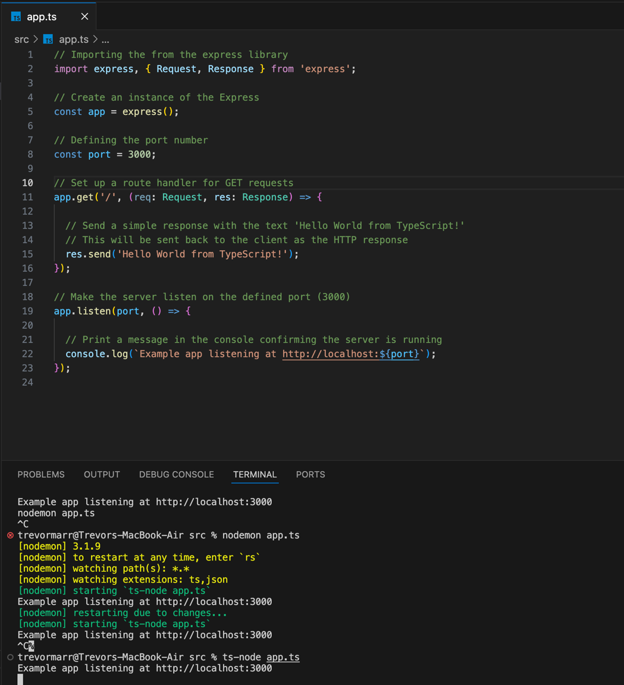

A screenshot showing the TS code with descriptive comments.